**ONLINE SHOPPING MANAGEMENT SYSTEM**

BY

LOK WERN KAI

A RIGOROUS ASSESSMENT

SUBMITTED TO

Asia Pacific University

JULY 2022

TABLE OF CONTENTS

**SOLUTION DESIGN**

Figure System Architecture Flow

The objective of this project is to develop an Online Shopping Management System for both business and customer user using C++ Object-Oriented Programming (OOP) concepts. The system should allow business user to manage user, inventory and order. On the other side, customer user should be able to browse product, place order and check bill via the system.

Since the main objective is to focus on application layer with OOP concepts, a simple console application with text file serve as data storage can meet the requirement and ease the development process. Console application can reduce the time on User Interface (UI) design and text file as data storage can avoid the time on setting up a Relational Database Management System (RDBMS). Hence, developer will have more time focus on application layer.

The console application will retrieve instruction from the user then save the input into the relative text file as data storage for future purpose. The user will be able to view the data stored in the text file via the application as well.

**ACTIVITY DIAGRAM**

Admin

1. Create User
2. Delete User
3. View User
4. Edit User
5. Search User

Manager

1. Create Product
2. Delete Product
3. View Product
4. Edit Product
5. Search Product
6. Create Order
7. Delete Order
8. View Order
9. Search Order
10. Create Order Item
11. Delete Order Item
12. View Order Item
13. Edit Order Item
14. Search Order Item

Customer

1. Search Product
2. Add Product to Cart
3. View Bill

**CLASS DIAGRAM**

1. Menu

1. Sub Menu
   1. AdminMenu

* 1. ManagerMenu

* 1. CustomerMenu

1. User
2. Component

**C++ PROGRAMMING CONCEPT**

1. **Variable**

Variable is one of the basic concepts in C++ programming. It is used to store and hold data values. In the application, variable such as username, password, file was declared to store the data for later use.

1. **Function**

A function is a block of code that are ready to be re-use. In C++, function can be used to perform certain action. Function such as toLower(), removeNewLine() and getNewOrderId were defined to fulfill the needs to convert string value to lower case, remove new line in the data and get new order id for new order.

1. **Control Statement**

Control statement in C++ is common use to redirect the flow of the program. It is heavily used in the application to deal with different condition and scenario.

* 1. **Conditional Statement**
     1. **If … else / else if … Statement**

Below screenshot shows an example of a nested If Else statement which return different string value with different condition such as is the product exists in database and is the class method successfully delete the product.

* + 1. **Switch Statement**

Switch statement is another common conditional statement to deal with multiple condition. In the application, it is used to route user to the correct menu based on the user permission.

* 1. **Loops**

In C++, looping is one of the control statements that will execute the code until it meets the defined condition.

* + 1. **While Loop**

A while loop in C++ will check the condition before it execute the code. Below screenshot is an example of while loop, it will retrieve the data in the text file line by line until it reaches the end of the file.

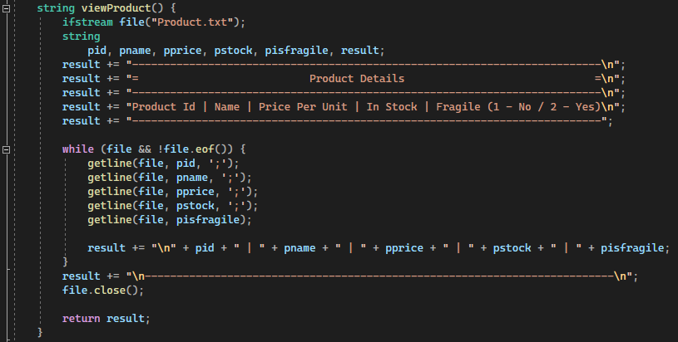

* + 1. **For Loop**

In C++, for loop can take up to 3 statement to execute the code. Below screenshot shows a for loop statement that will loop every single character in a string data, convert it to lower case and append the converted character to a string data.

* + 1. **Do…While Loop**

Do While loop is a reverse version of while loop. Do while loop will execute the block code for the first time then loop in if the condition is met. In the application, it was used to repeat menu screen to user until user opt to exit the application.

**OBJECT ORIENTED CONCEPT**

1. **Class**

A Class in C++ programming is the main aspect of OOP. It allows the developer to follow the “Don’t Repeat Yourself” principle during development. In below screenshot, multiple class such as User, Admin, Manager and Customer were defined to create different object in the application.

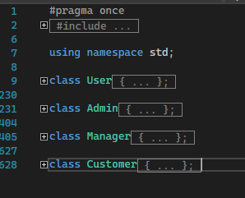

1. **Constructor**

A Constructor is a special class method that will be execute when a new object is created.

In the application, the Order class have different constructor to handle different scenario when the application creates an Order object.

1. **Encapsulation**

Encapsulation in OOP is to ensure that data are hidden from the users and can only access by the class itself. From below screenshot, variable such as password, isExit, permission and username fall under private access specifier. User only allow to access the data via in-class get and set method.

1. **Inheritance**

Inheritance in OOP is to allow developer defined sub-classes from a base class, so that the method and variable in the based class can be re-use by the sub-classes. From below screenshot, Admin class is a sub-class of User class. When an Admin object require to list out customer, it can call the viewCustomer() method without create another User object.

1. **Polymorphism**

Polymorphism allow OOP in C++ to have method with same name but work in different way. From below screenshot, there are 3 different Order method which behave differently and overload each other. It was designed to fit different use case in the application.

1. **Abstraction**

Encapsulation in OOP is to ensure that data are hidden from the users and not accessible outside from the class. From below screenshot, variable such as password, isExit, permission, username and delCart() method falls under private access specifier which user can’t access the data from the outside. However, public method such as Cart are callable when the user creates a Cart object.

**PROGRAMME SCREENSHOT**

Admin

1. Create User
2. Delete User
3. View User
4. Edit User
5. Search User

Manager

1. Create Product
2. Delete Product
3. View Product
4. Edit Product
5. Search Product
6. Create Order
7. Delete Order
8. View Order
9. Search Order
10. Create Order Item
11. Delete Order Item
12. View Order Item
13. Edit Order Item
14. Search Order Item

Customer

1. Search Product
2. Add Product to Cart
3. View Bill

**TEST CASE**

**LIMITATION**

Beside of the functionality of the system, system limitation comes together.

* Data Verification, address checking, phone number checking
* Apply role for better user management
* Manager add order won’t generate bill

**CONCLUSION**